OVERVIEW
WHEELCHAIR BASKETBALL INFORMATION FACT SHEET
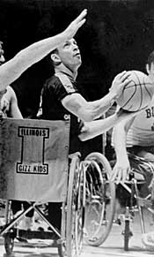
World War ll veterans in the United States first developed wheelchair basketball between 1945 and 1946. The sport has since grown into an international sport that is played in over 80 countries. Wheelchair basketball is played by both men and women who compete in the same athletic tradition and spirit as regular basketball.
HISTORY
In the mid 1940’s, a similar sport Wheelchair Netball was being played at the spinal Rehabilitation Hospital in Great Britain as a form of rehabilitation. In 1955, the first international Wheelchair competition took place between the U.S. Wheelchair Basketball team and the Pan Am Jets at the Stoke Mandeville Games in Great Britain. The game lacked basketball backboards because the English team played netball, but backboards became standard soon after.
The International Stoke Mandeville Federation was the world governing body for wheelchair sports until 1973, when a special division was created for wheelchair basketball, called the International Wheelchair Basketball Federation in 1989.
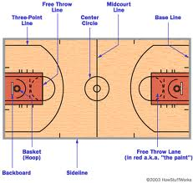
WHEELCHAIR BASKETBALL COURT
The Wheelchair athletes compete on the same size basketball court as able-body basketball players (94 feet by 50 feet), the height of the baskets are the same (10 feet of the ground)
TEAM BREAKDOWN / POINTS
Wheelchair basketball teams have a maximum of 12 players. A maximum of five players are on the court during game play. Each player is given a point value according to the severity of their
disability. Point values start at 1 point for the most severely disabled player to 4.5 points for the player with the most functional abilities. Each team’s total point value must not exceed 14 points for the players on the court at any given time.

CONTROL OF POINTS ON THE COURT
The official scorer is responsible for seeing that the players on the court for either team at any time does not exceed the fourteen (14) points. (This only has to be checked at the start of each half and at the time of substitutions.) At any time during the game, if it identified that a team exceeds the “PLAYER POINT LIMIT” a Technical Foul is called against the team in violation and handled as all other Technical Foul ( 2 Foul Shots), with a correction in the line up being made at that time.
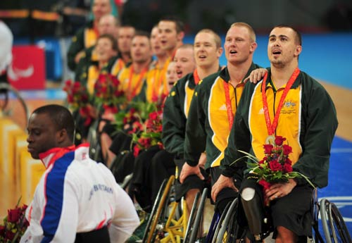
AUSTRALIAN ROLLERS RESULTS
Paralympic Games 1996- GOLD
Paralympic Games 2004- SILVER
World Championships 2006- BRONZE
Paralympic Games 2008 – GOLD
Paralympic Games 2010 - GOLD

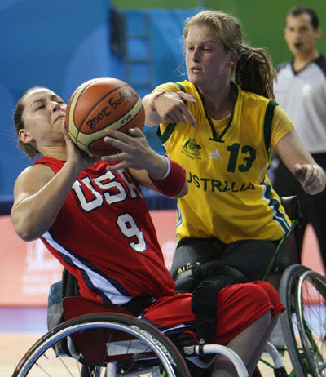
AUSTRALIAN GLIDERS RESULTS
World Championships 1994 - BRONZE
World Championships 1998 – BRONZE
Paralympic Games 2000 – SILVER
World Championships 2002 – BRONZE
Paralympic Games 2004 – SILVER
Paralympic Games 2008 - BRONZE

